EXPERIMENT 8

Text Generation using Hugging Face Inference API

Name | N.Vinay Yadav
Register Number | 192472061

AIM
To demonstrate text generation for a prompt using a sample Hugging Face-style response.

PROCEDURE
- Open a Python editor or notebook.
- Display a predefined prompt asking to explain Python.
- Prepare a sample response describing Python.
- Print the prompt and generated text.
- Run the program and observe the output.

PROGRAM
print("Text Generation using Hugging Face API")

prompt = "Explain Python" print("\nPrompt:", prompt)

generated_text = """
Python is a popular programming language. It is simple, powerful and easy to learn.
It is used in AI, machine learning and web development. """

print("\nGenerated Text:") print(generated_text)

OUTPUT
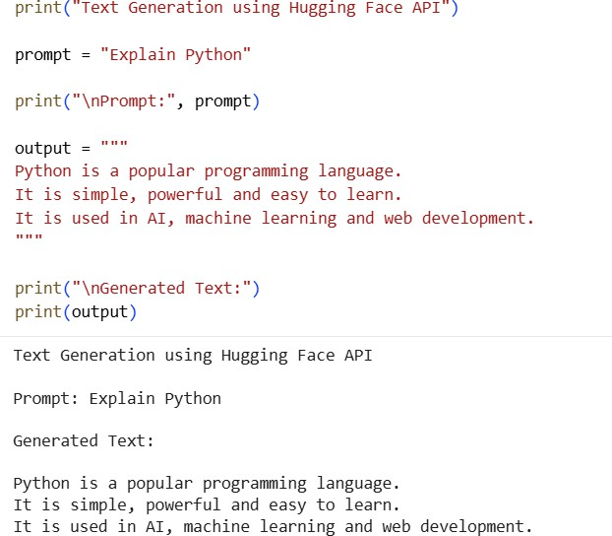

RESULT
Thus, the program demonstrating text generation using a Hugging Face-style prompt was executed successfully.

